The Impossible Dance
Tune: William Taylor's Tabletop Hornpipe, by William Taylor Set: 6 dancers, 32“ (long) sticks, single steps Source: Boggart's Breakfast Chorus: spin & toss. Repeat. Figures: hot cross buns, collapse the set, swiss roll, spotted dick

Figures

Hot Cross Buns
Pass through, turn over left (teflon shoulder), go 1/4 of the way around counter-clockwise into a set that's 90° rotated from the original. Repeat a total of 4x

Collapse the Set

Swiss Roll
Spin over left (stick) shoulder as odds go down & evens go up. Odds come back up & evens back down on the opposite side of the set from where they were. Repeat a total of 4x

Spotted Dick
Easy turn over left shoulders to a single line with pairs facing each other. Turn over right (stick) shoulder to perpendicular set. Repeat 4x

Chorus
Diagonal toss, spin to reorient the set, toss & clash in new positions.
Repeat a total of 4 times to end up in home positions.
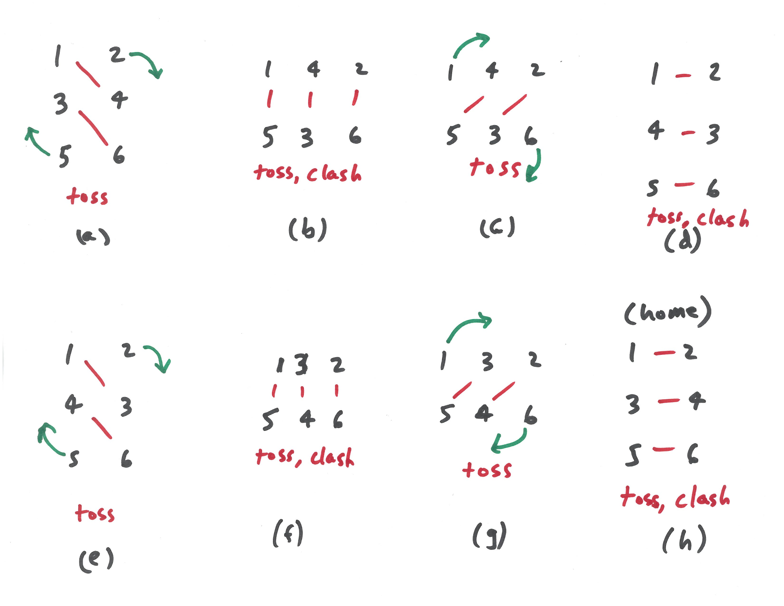Impossible Dance Chorus

Tune

